Carols for
Candlemas

Cantilena

Conductor: Jenny Hansell

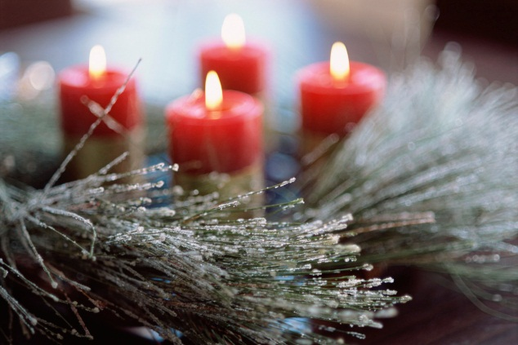

Saturday 8th February 2014
7.30 pm
St Michael and All Angels, Partridge Green

PROGRAMME

Resonemus laudibus anon. 14th century
Nowell sing we anon. 15th century

O Regem coeli Tomás Luis de Victoria (1548-1611)
Lullay, my child and weep no more Peter Aston (1938-2013)
O magnum mysterium Cristóbal de Morales (1500-1553)

Verbum caro factum est anon. 12th century
Alma redemptoris mater Josquin Des Prez (c1440-1521)

A babe in Bethlem’s manger laid Patrick Hadley (1899-1973) (Rosemary Hensor – Piano)
Adorna thalamum tuum William Byrd (c1540-1623)

Dieus soit en cheste maison Adam de la Halle (fl. mid 13th century)

In the bleak midwinter Benjamin Britten (1913-76)

SHORT INTERVAL

A Christmas Garland George Dyson (1883 -1964)
(Elizabeth Burtenshaw – Piano)

Refreshments will be served after the concert

