Hymns to the Virgin
Music across the centuries in honour of the Virgin Mary

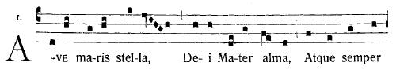

CANTILENA
Director: Jenny Hansell

Saturday 11th October 2014
7.30pm

St John’s Church,
Broadbridge Heath, RH12 3LD

www.cantilenachoir.jimdo.com
PROGRAMME

Three Medieval Motets:
Ave Maris Stella Guillaume Dufay (c1400-1474)
Sancta Maria John Dunstable (c1370-1453)
Ave Regina Caelorum Dufay

The Renaissance Master:
Ave Regina Caelorum Giovanni Pierluigi da Palestrina
Hodie Maria Virgo (1525-1594)

Three French Baroque Motets:
Regina Caeli Laetare H32 Marc-Antoine Charpentier
Salve Regina H23 (1645-1704)
Ave Regina Caelorum H19

SHORT INTERVAL

A French Salutation:
Magnificat H75 Charpentier

Veneration of the Virgin in Italy:
Alma Redemptoris Mater Palestrina
Laudi alla Vergine Maria Giuseppe Verdi (1810-1883)

Three Twentieth Century settings of Ave Maria:
Ave Maria Michael Head (1900-1976)
Ave Maria Cecilia McDowall (b 1951)
Ave Maria Gustav Holst (1874-1934)

